Ec2 challenges
Launch one EC2 instance using Amazon Linux 2.
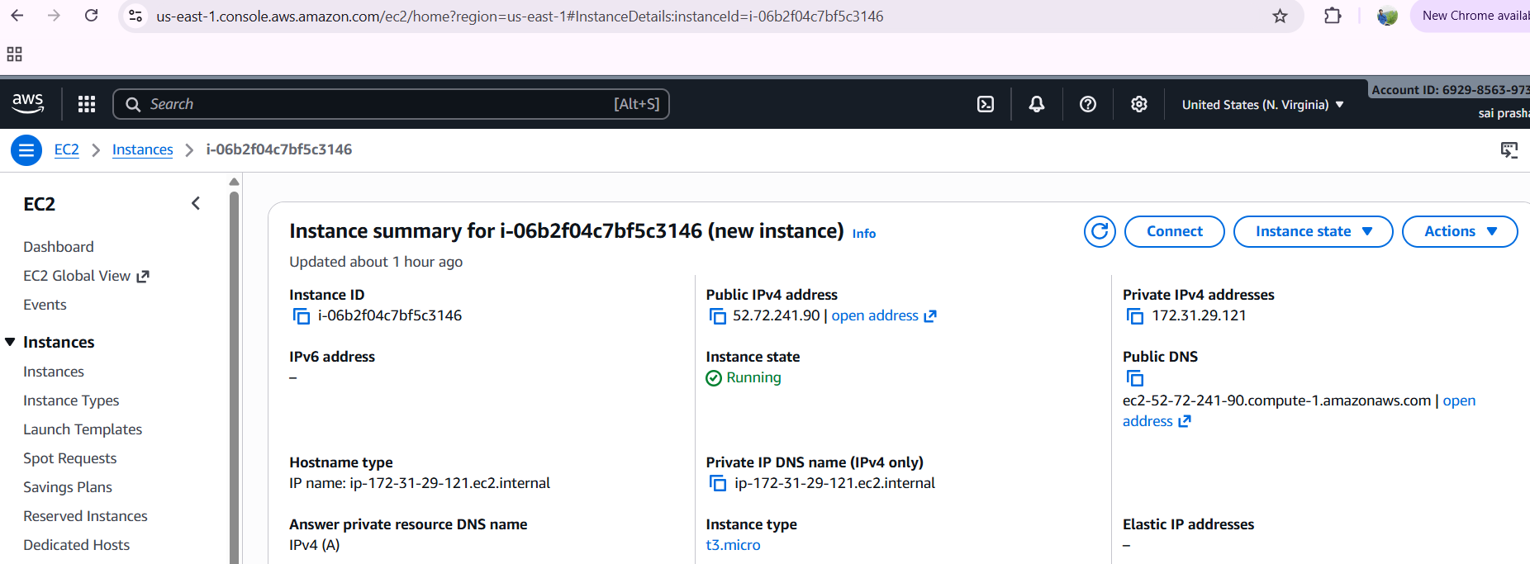
- Install Docker.
first copy the ssh instance to git bash
switch to root user
yum update -y
yum install docker
systemctl start and status docker
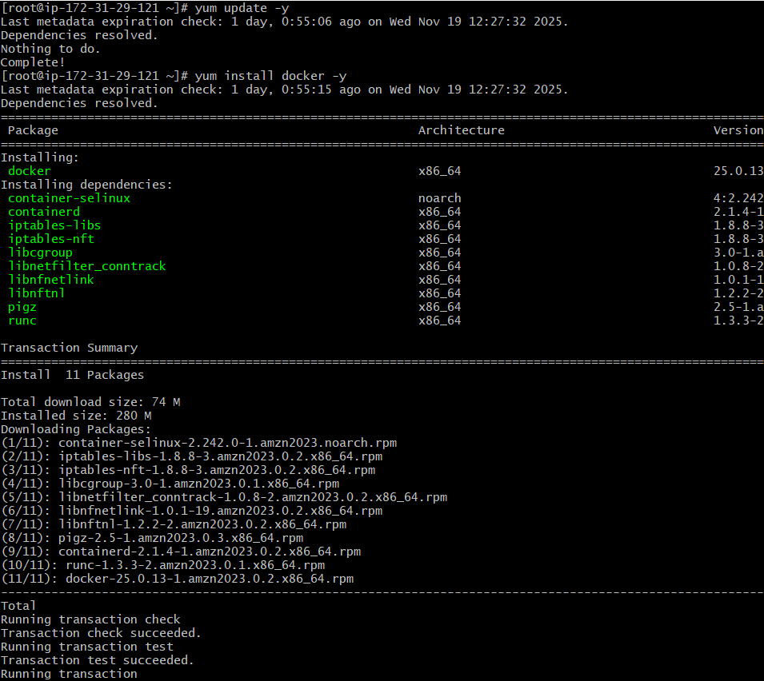
to check docker version
use docker –version
to start and status of docker
systemctl strat docker
systemctl status docker
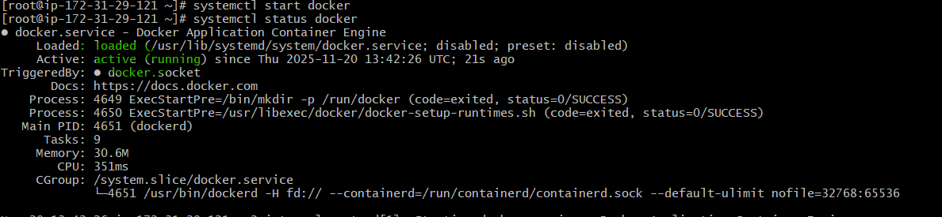

- Install Jenkins.
first install java. for latest version install jdk 17
use the command yum install java-17-amazon-corretto -y
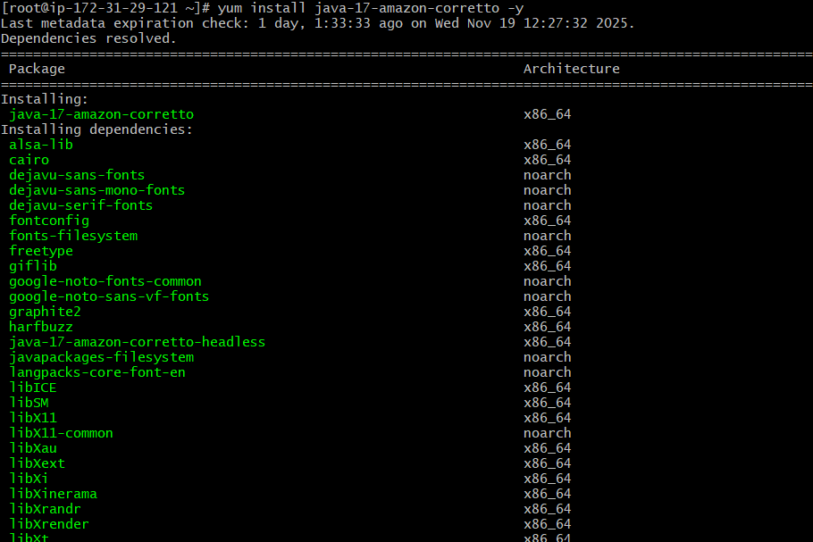
then check the java -version
to install Jenkins sudo yum install jenkins -y
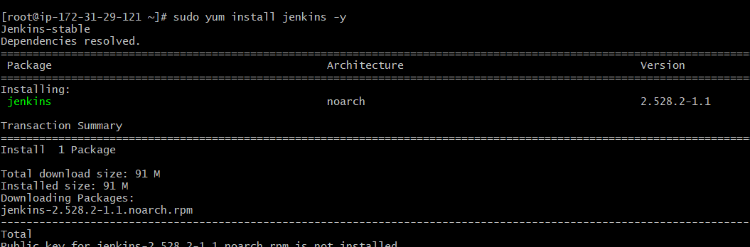
to enable, start and status of Jenkins
sudo systemctl enable Jenkins
sudo systemctl start Jenkins
sudo systemctl status Jenkins
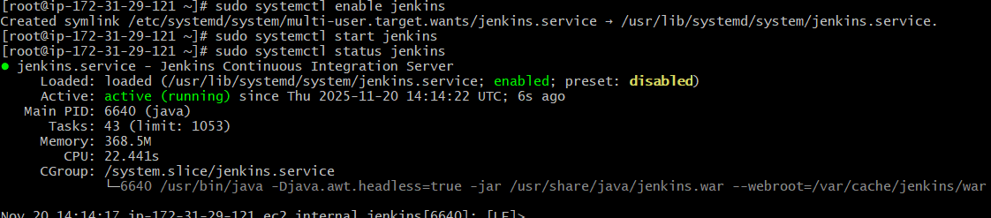
after installation check with the oublic id in browser
Jenkins runs on port number : 8080
to get password copy the administration path and in gitbash do cat and pstae the path
you will get the password and now paste it in password field
Jenkins has been started as admin
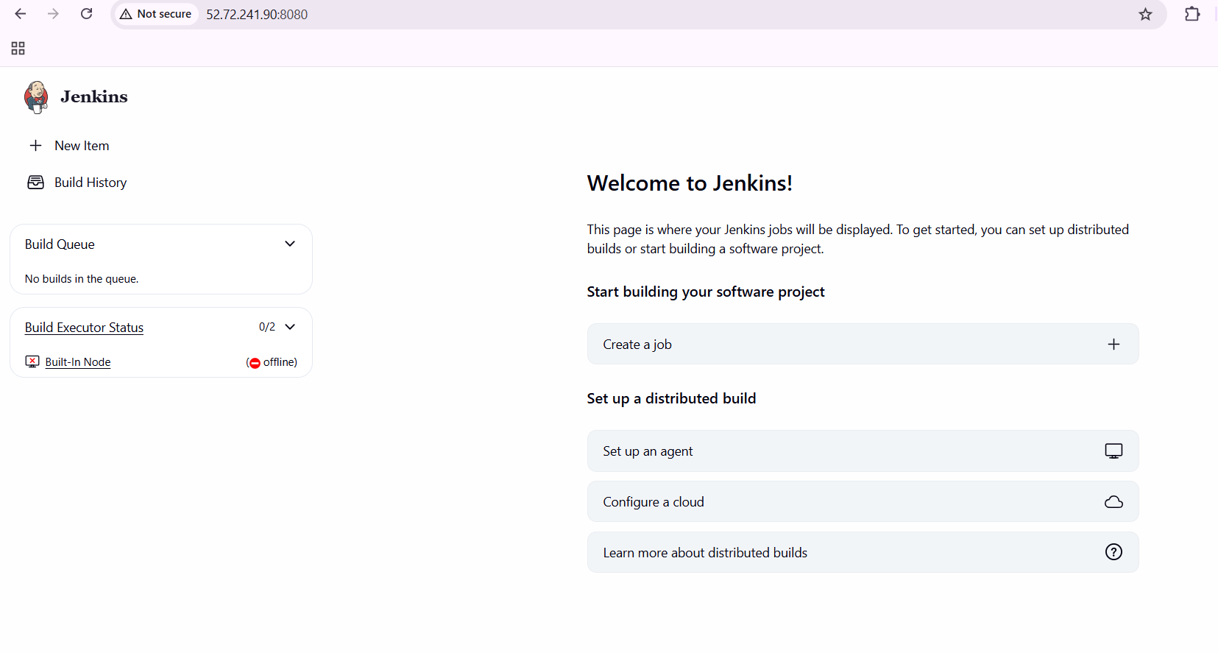

- Install Apache.
first yum install httpd -y
systemctl start httpd
systemctl status httpd
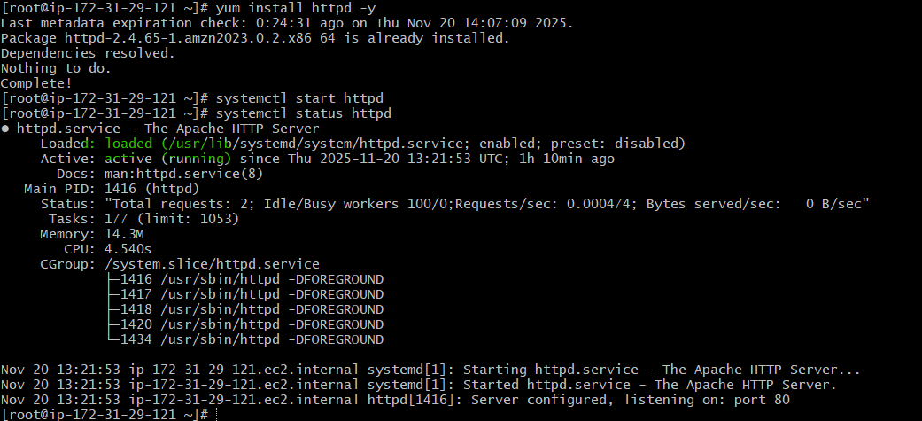
to run the httpd we use port number 80
now run with same public id and add :80
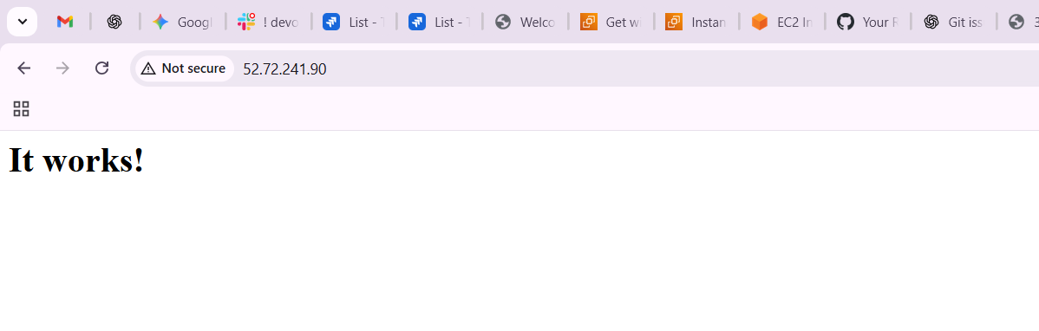
- Install Nginx.
yum install nginx-y
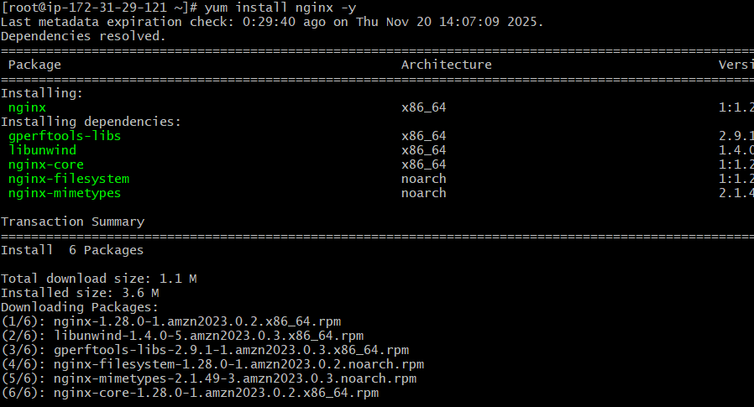
after getting installed we need to run with same public id
default port number for nginx is 80
to run with different port number we need to do configuration and change the port number 80 to 81 as in port number 80 httpd is already running
use vi /etc/nginx/nginx.conf
and edit the number 80 to 81
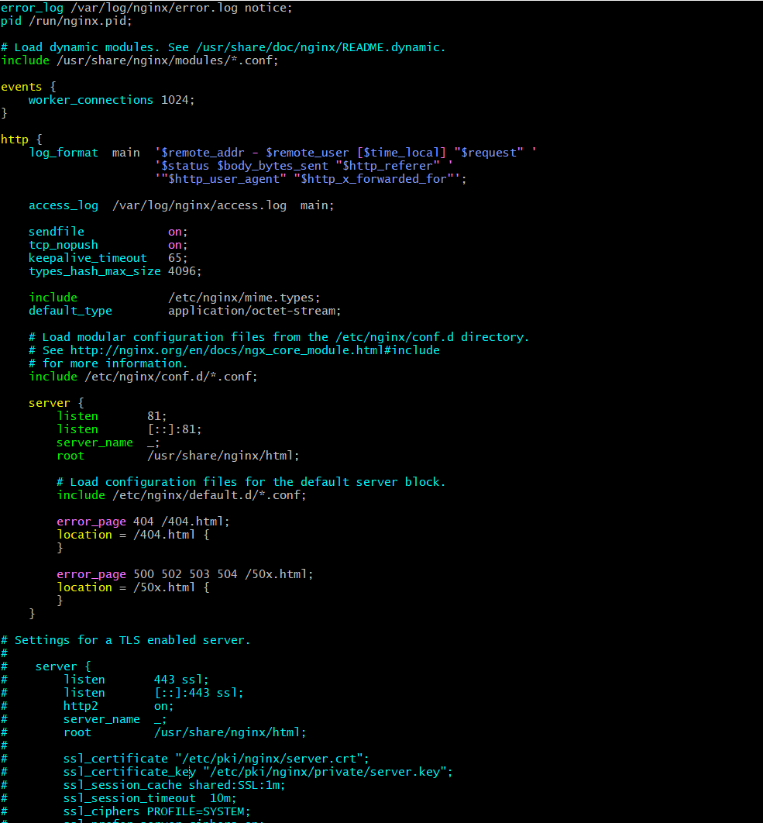
finally the nginx is running on port number 81
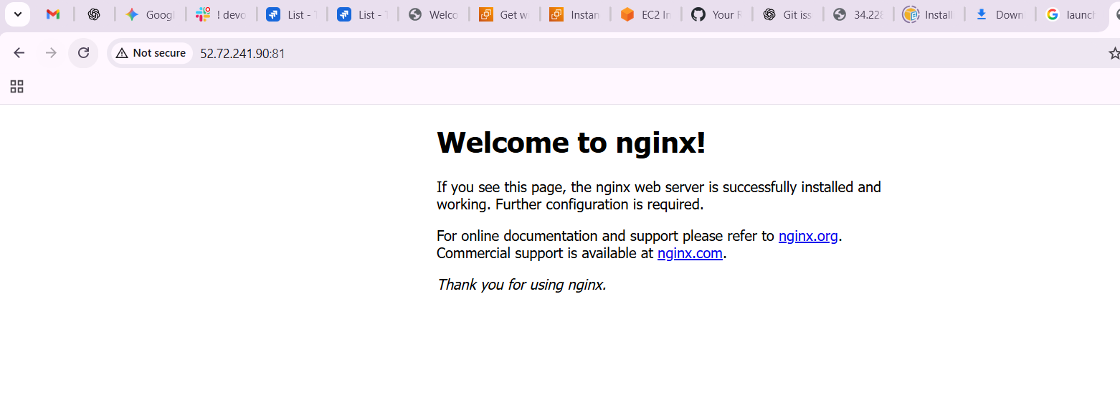

- Install Apache Tomcat.
first create one back cd opt/
go to browser and tomcat downloads
copy the tar link address
wget and paste the link
now extract the file using tar xvf
move the extracketed file into tomcat
mv apache…. tomcat
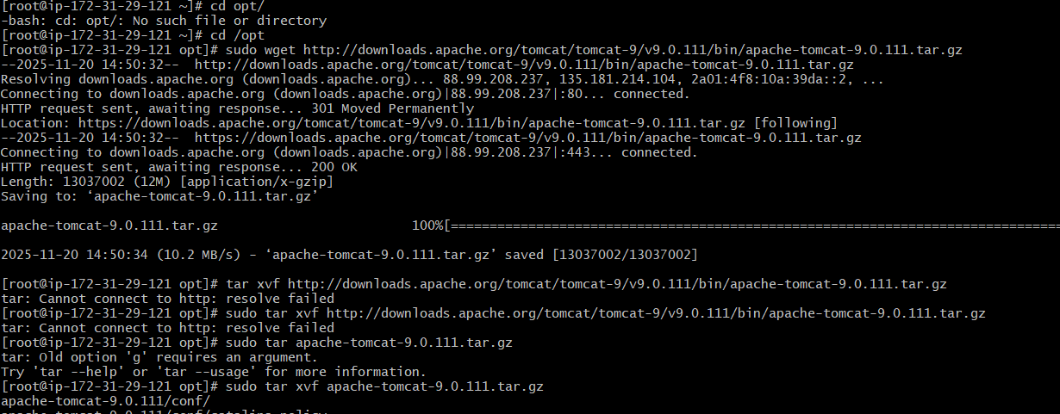
come to tomcat directory cd tomcat/
if you give ls u can see bin conf etc…
cd conf
ls
u can see server.xml
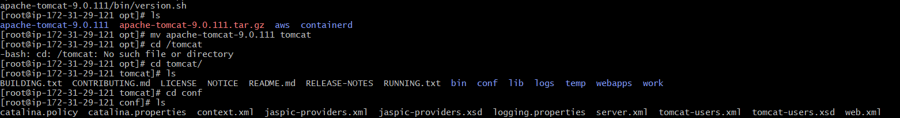
go to vi server.xml for configuration from 8080 to 8082
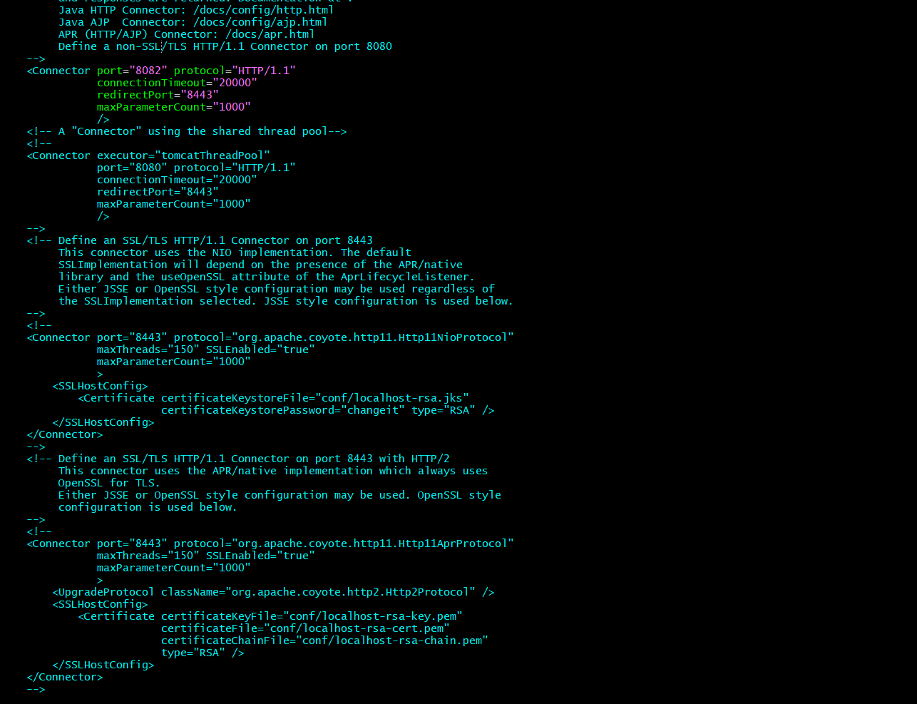
then
cd bin/
ls
./startup.sh
finally the tomcat has been executed in port number 8082
